**House Price Prediction**

**Capstone Project Report**

Neeraj Walia

Capstone Project

# Abstract

House search for a first time home buyer is a daunting task. It involves research for house, talk to realtors, applying for bank loan, getting finances in order. There is tremendous amount of data available related to any house and its past sales history. In this project, I want to tackle “research for house” part of the home buying experience and make it easier for the home buyer to do their analysis and narrow down the choices to few neighborhoods or houses to pick from.

# Introduction

As a home buyer, there are many tools (or websites) available where you can search for the houses that are already in market and check the asking price. But there is a need for a tool that will help home buyer research homes and predict the price of the house based on their wish list. It could be combination of requirements that user may have like location, number of bedrooms, bathrooms, single family or townhouse, square footage etc.

This project is to provide an easy to use tool to home buyers where they can enter their requirements and find out potential prices for the house. Using this tool they can compare their budget with the predicted price of the house and make adjustment to prioritize their requirements.

# Context

I am building a website which is very visual and easy to understand. The website is divided into two parts “history of homes sold” and “Potential prices of houses not currently in market (predictive)”. Technology am using is python for data exploration, analysis, building model for prediction. For website building am using Tableau Public, it’s a free service available for up to 10GB of data. It is a few restrictions for free version as which data sources we can connect to but for this project it will work. Tableau is picked for its impressive visualizations.

Data is available on kaggle website under the following link

<https://www.kaggle.com/c/house-prices-advanced-regression-techniques/data>

# Question

The goal of this website is to predict the prices of the houses before they are put on sale by their owners. This can be based on various factors like neighborhoods, sq. footage, number bedrooms, bathrooms, house condition, year built, garage, type of roof, type of air conditioning etc. There are over 80 variables to pick from and make prediction.

# Data

There are two sets of data available train and test set. Both have 1460 records in them. Each row represents a house and its information. Train set has 81 features including Sales price (target) which we will use to train our model. Test data set have 80 features and we will make prediction the houses in this data set.

Data is available on kaggle website. And the link is provided above under context section. Data cover all details about the house. There are total 81 features and details everything related to the house. It has both categorical and numerical features. There are 37 numerical and 44 categorical features.

Lots of effort has been gone into translating categorical features into integer without changing its weightage. So features translate equally when they were as categorical as well as numerical

Below is the brief description about each feature. More detailed description is at the end of this report under data dictionary section.

|  |
| --- |
| MSSubClass: type of dwelling like DUPLEX - ALL STYLES AND AGES, 2 FAMILY CONVERSION - ALL STYLES AND AGES, 2-STORY PUD - 1946 & NEWER etc. |
| MSZoning: zoning classification like agriculture land, commercial, Floating Village Residential etc. |
| LotFrontage: linear feet of street connected to property |
| LotArea: Lot size in square feet. |
| Street: type of road access to property like paved gravel. |
| Alley: type of alley access to property like no alley access, paved, gravel. |
| LotShape: shape of property like regular, slightly irregular etc. |
| LandContour: flatness of the property like near flat/level, banked, hillside, low etc |
| Utilities: type of utilities available like all public, noSewr, electric only etc. |
| LotConfig: Lot configuration like inside lot, corner, cul-de-sac |
| LandSlope: Slope on property like gentle, moderate, sever etc |
| Neighborhood: Physical location name of street or location |
| Condition1: proximity to various locations like artery, adjacent to feeder street, normal etc. |
| Condition2: proximity to various conditions like adjacent to arterial street, normal etc. |
| BldgType: type of dwelling like single family, duplex etc. |
| HouseStyle: 1 story or 2 story etc |
| OverallQual: Rates the overall material and finish of the house like excellent, good, average, poor etc. |
| OverallCond: Rates the overall condition of the house like excellent, good, average, poor etc. |
| YearBuilt: Original construction date |
| YearRemodAdd: Remodel date (same as construction date if no remodeling or additions) |
| RoofStyle: Type of roof like gable, gabrel, hip etc |
| RoofMatl: Roof material |
| Exterior1st: exterior covering on house |
| Exterior2nd: Exterior covering on house if more than one |
| MasVnrType: Masonry veneer type like brick common, brick face etc |
| MasVnrArea: Masonry veneer area in square feet |
| ExterQual: Evaluates the quality of the material on the exterior |
| ExterCond: Evaluates the present condition of the material on the exterior |
| Foundation: type of foundation like Brick & Tile |
| BsmtQual: Evaluates the height of the basement like Excellent (100+ inches), Good (90-99 inches), Typical (80-89 inches), Fair (70-79 inches), Poor (<70 inches), No Basement |
| BsmtCond: Evaluates the general condition of the basement |
| BsmtCond: Evaluates the general condition of the basement |
| BsmtExposure: Refers to walkout or garden level walls |
| BsmtFinType1: Rating of basement finished area |
| BsmtFinSF1: Type 1 finished square feet |
| BsmtFinType2: Rating of basement finished area (if multiple types) |
| BsmtFinSF2: Type 2 finished square feet |
| BsmtUnfSF: Unfinished square feet of basement area |
| TotalBsmtSF: Total square feet of basement area |
| Heating: Type of heating like floor, GasA, GasW, Grav |
| HeatingQC: Heating quality and condition |
| CentralAir: Central air conditioning |
| Electrical: Electrical system |
| 1stFlrSF: First Floor square feet |
| 2ndFlrSF: Second floor square feet |
| LowQualFinSF: Low quality finished square feet (all floors) |
| GrLivArea: Above grade (ground) living area square feet |
| BsmtFullBath: Basement full bathrooms |
| BsmtHalfBath: Basement half bathrooms |
| FullBath: Full bathrooms above grade |
| HalfBath: Half baths above grade |
| Bedroom: Bedrooms above grade (does NOT include basement bedrooms) |
| Kitchen: Kitchens above grade |
| KitchenQual: Kitchen quality |
| TotRmsAbvGrd: Total rooms above grade (does not include bathrooms) |
| Functional: Home functionality (Assume typical unless deductions are warranted) |
| Fireplaces: Number of fireplaces |
| FireplaceQu: Fireplace quality |
| GarageType: Garage location |
| GarageYrBlt: Year garage was built |
| GarageFinish: Interior finish of the garage |
| GarageFinish: Interior finish of the garage |
| GarageArea: Size of garage in square feet |
| GarageQual: Garage quality |
| GarageCond: Garage condition |
| PavedDrive: Paved driveway |
| WoodDeckSF: Wood deck area in square feet |
| OpenPorchSF: Open porch area in square feet |
| EnclosedPorch: Enclosed porch area in square feet |
| 3SsnPorch: Three season porch area in square feet |
| ScreenPorch: Screen porch area in square feet |
| PoolArea: Pool area in square feet |
| PoolQC: Pool quality |
| Fence: Fence quality |
| MiscFeature: Miscellaneous feature not covered in other categories |
| MiscVal: $Value of miscellaneous feature |
| MoSold: Month Sold (MM) |
| YrSold: Year Sold (YYYY) |
| SaleType: Type of sale |
| SaleCondition: Condition of sale |

# Analysis

Sales price of the house is the target of our analysis and its distribution is as follows.

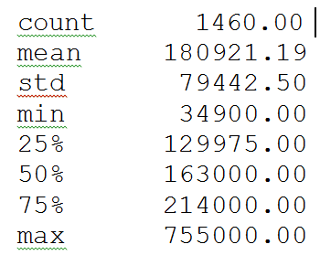 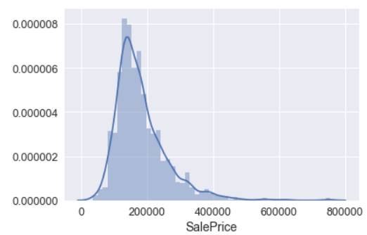

The skewness of the data is 1.88 meaning it is highly skewed. We could use log transformation to make it normally distributed.

We will plot lots of scatter plot to see relation between sales and each individual feature to see their relationship.

Above ground living area in square feet has a direct relationship with Sales Price. Higher the area higher is the sales price so it looks like a linear relationship.

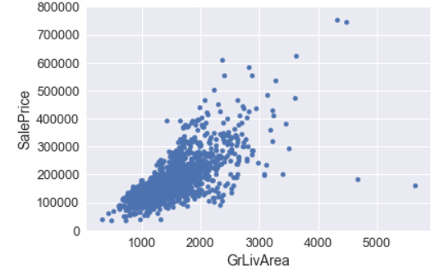

Similarly basement square feet has a direct relation to sales price

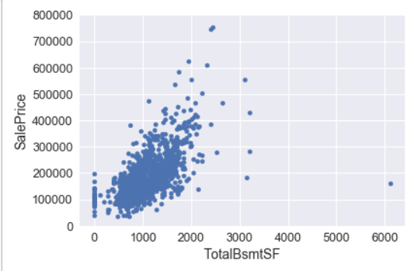 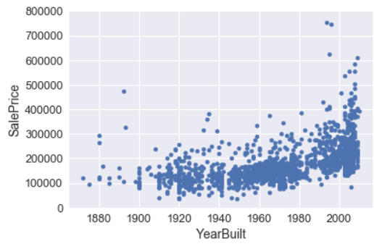

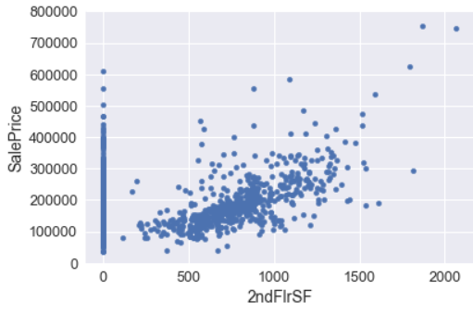 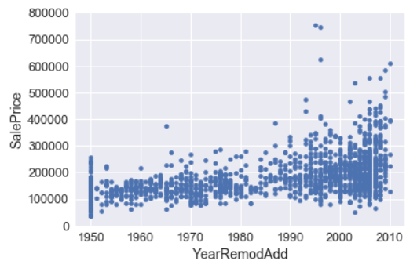 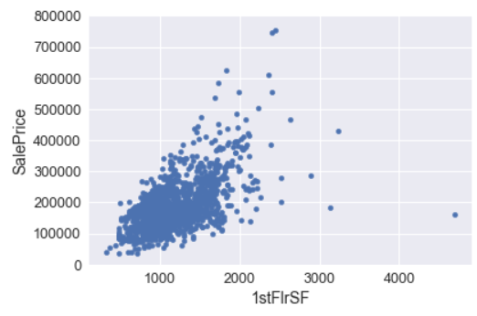 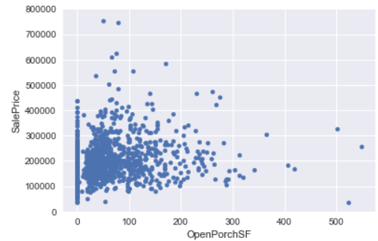

Following graph shows year when the house was build vs sale price. Price of older homes and newer homes has wide range of sales price. This also depends on other features like living square footage, condition of the house etc.

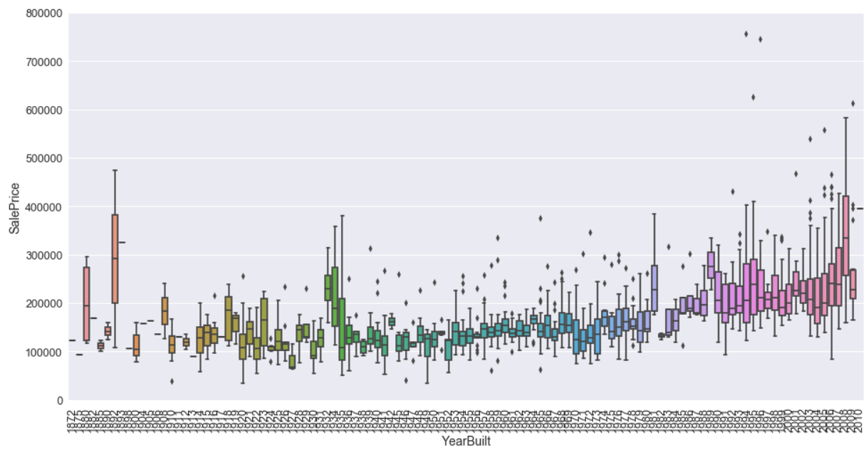

Missing Values: There are many NA values in our data set as shown by the graph below. But upon closer looks it shows that NA has specific meaning for that particular feature. For example, PoolQC there are over 1400 values with NA but that means no pool in the property.

**NA values in Dataset**

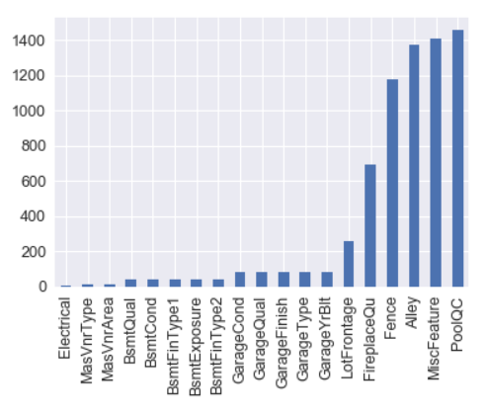

MiscFeature feature “miscellaneous feature not covered in other categories” defines NA as none.

Similarly, Alley NA is defined as no alley access. Therefore, we need to keep these values as this provides information about the house.

Few features are removed from both Train and Test dataset either because of large NA values or their information was already available in other features. Features that are removed are LotFrontage, MasVnrType, MasVnrArea and GarageYrBlt.

I am going to convert categorical values into numerical by using one_hot_encoding method from sklearn. This transformer converts categorical feature into one hot numeric array. So, this transformer assigns binary integer to distinct categorical values in each feature and creates a new column for it. For example:

**Old Alley** **New columns** to identify three values of Alley

|  |
| --- |
| Alley |
| Grvl |
| NA |
| Pave |

|  |  |
| --- | --- |
| Alley_Grvl | Alley_Pave |
| 1 | 0 |
| 0 | 0 |
| 0 | 1 |

Final train data set after One_hot_encoding transformation was applied has 282 Columns. Now all categorical values are represented as numerical values. We also need Test dataset to have same features as train model for prediction model to work. Issue is test does not have all the data as of train dataset. For example as shown above “Alley” may not have any data for Paved alley in the test dataset. And due to this scenario Alley_Pave column will be missing from final test dataset. To avoid this situation am going to do left join with train data so all columns that are there in train will be in test as well with NULL values.

*one_hot_encoded_training_predictors = pd.get_dummies(df_train)*

*one_hot_encoded_test_predictors = pd.get_dummies(df_test)*

*final_train, final_test = one_hot_encoded_training_predictors.align(one_hot_encoded_test_predictors, join='left', axis=1)*

And for the new columns that are added in test dataset, am going to replace NULLS with zeros as would imply that those feature is not present in the house.

*#fill missing values in final_test with 0 since those features are not available*

*final_test.fillna(0, inplace = True)*

Below is the heat map for top 10 variables in correlation matrix from final train data

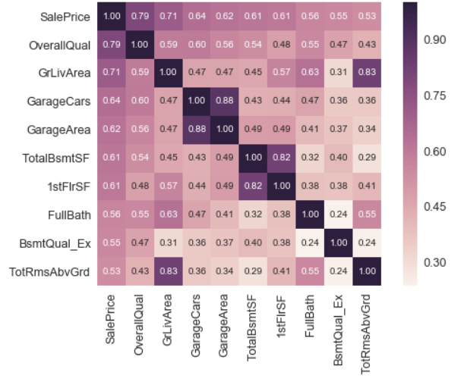

**Feature Selection**

At the time of model building, training the model on a sample data and use prediction function to predict same data leads to mistakes called **overfitting**. To avoid this situation data should be data should be split into test and train data, so model is trained on train data and tested on test dataset. But the percent of split between train and test data is still controlled manually and can be tweaked to receive favorable results. This problem can be solved by solution called cross-validation, this approach is based on k-folds cross validation. Data is split into k samples and model is trained on (k-1) samples. Resulting model is tested against remaining data. This process is repeated multiple times and performance is measured by the average of the values computed in the loop.

I will be using sklearn cross-validation cross_val_score function for feature selection in this project.

*cross_validation.cross_val_score(model_name,X,y,cv=5, scoring='mean_squared_error')*

*X: Original Data (final train in our case)*

*Y: target data (Sale Price)*

*cv: Number of times cross validation will repeat*

*scoring = Mean squared error*

**Linear regression**

I am going to build linear regression model because as discussed above there are linear relations between Sales price and independent variables.

*lm = LinearRegression()*

*lm.fit(X_train, y_train)*

*score =cross_validation.cross_val_score(lm,X,y,cv=5, scoring='mean_squared_error')*

*mse_score = -score*

*rmse_score = np.sqrt(mse_score)*

*rmse_score.mean()*

*Root mean square of Linear regression is* 35154.66

**Random forest Regressor**

Random forest is an estimator that fits classifying decision tree on various samples of data and uses average to improve the predictive accuracy and control overfitting.

*rf = RandomForestRegressor(n_estimators = 1000, random_state = 42)*

*rf.fit(X_train, y_train)*

n_estimator is the number of trees in random forest.

Random_state is the see used by the random number generator.

Fit builds the random forest regressor model for the train data.

*rf.predict(final_test)*

Predicts the data for the final test data set.

rf = RandomForestRegressor(n_estimators = 1000, random_state = 42)

# Train the model on training data

*rf.fit(X_train, y_train)*

*score1 =cross_validation.cross_val_score(rf,X,y,cv=5, scoring='mean_squared_error')*

*mse_score1 = -score1*

*rmse_score1 = np.sqrt(mse_score1)*

*rmse_score1.mean()*

Here we will build the random forest regressor model with 100 estimators, fit the model with training data. Run cross validation cross_val_score function five times on the random forest regressor model on training data. Calculate the Root mean square error.

Root mean square error of Random Forest Regressor is 29921.69

The Random Forest Regressor model is the winner of this analysis with lower root mean square error. The prediction nfor the final_test data is going to be made based on this this model.

# Website

Using the historical data (train dataset) and new predictive model (test dataset), a new website is developed and its link is given below. I have used Tableau for the design, development and hosting of the website.

<https://public.tableau.com/profile/neeraj3209#!/vizhome/AmnesHousing/AmnesHousing>

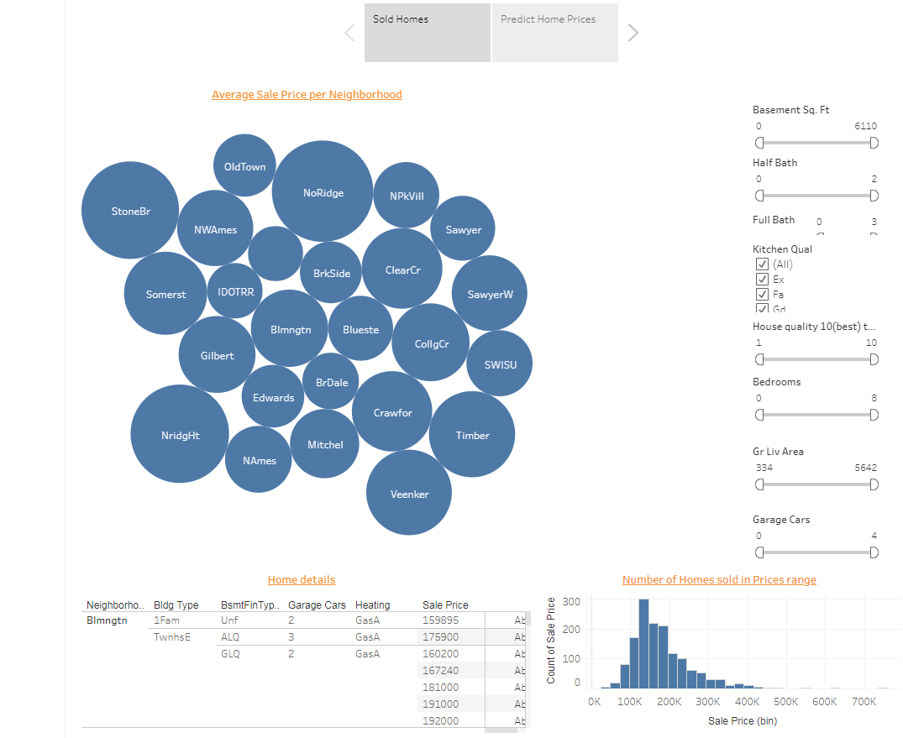

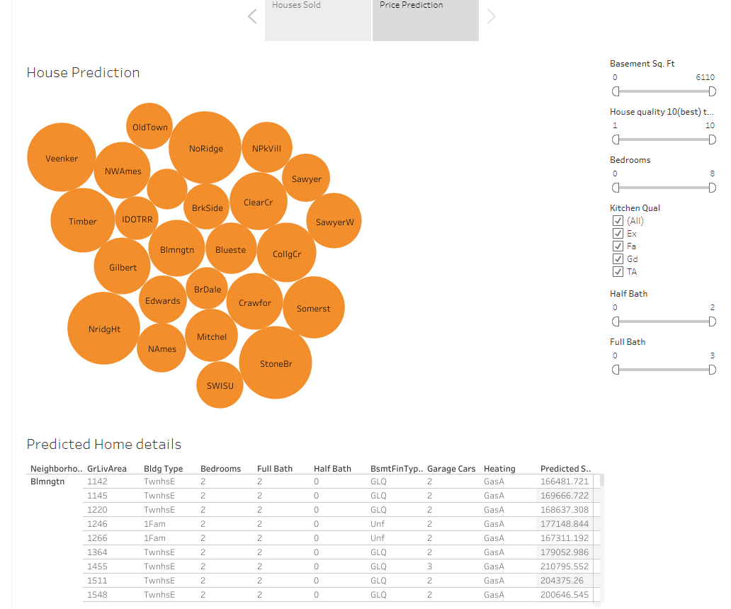

# Data Dictionary:

Attached is the data dictionary file for detailed description of each feature.

